# PERFORMANCE TESTING

Testing the stability and response time of an application by applying load is called as Performance Testing.

***Stability***: Ability of an application to withstand load

***Load***: Designed number of users

***Response time***: It is the total time (t) taken to receive the request (t1), execute the program (t2) and send the response (t3).

T= t1 + t2+t3

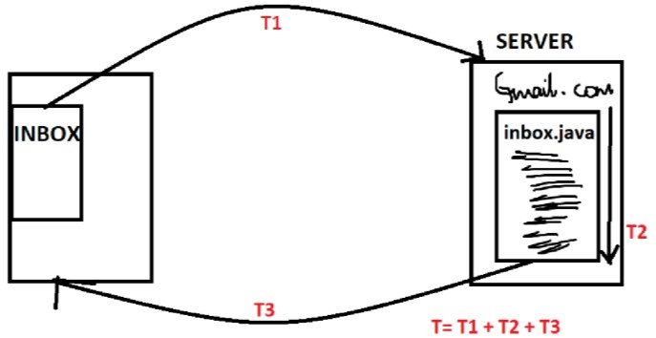

**Performance tools available in market**

1. J meter
2. Neo load
3. Load runner
4. Rational performance tool
5. Silk performance tool

**How to do performance testing using J meter?**

1. Take performance testing tool (J-meter), write the scripts
2. Click on run, it will ask you how many users (enter 1lakh and click on run)
3. 1 lakh requests are fired to the server now there is a heavy load on the server
4. Server sends the response to the performance testing tool
5. Tool analyze the response and gives the result in the form of graph
6. TE should analyze the result and decide whether test is pass or fail
7. If it is failed then send it to the developers they will alter/change the code to improve the Performance i.e. they do "performance tuning"
8. Once again TE should run the test script
9. Repeat all the steps

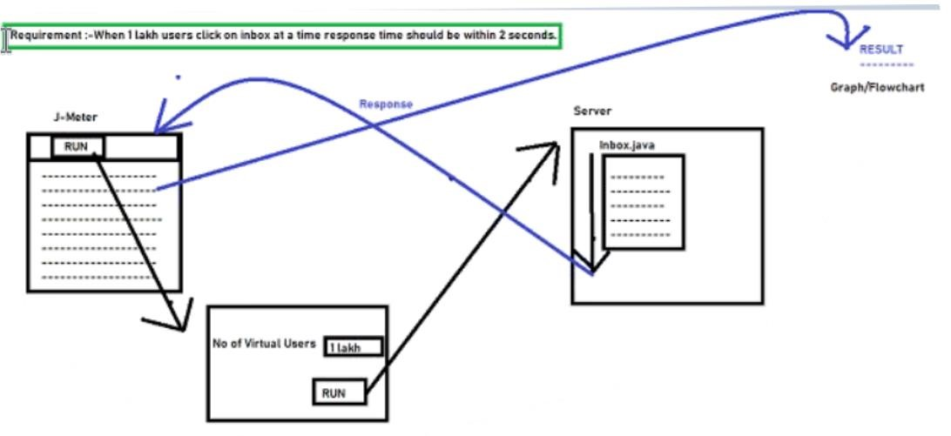

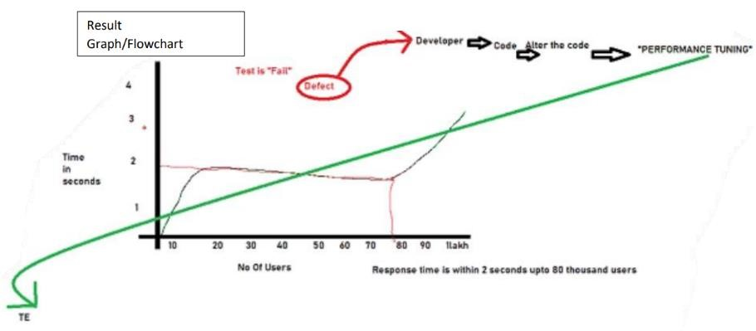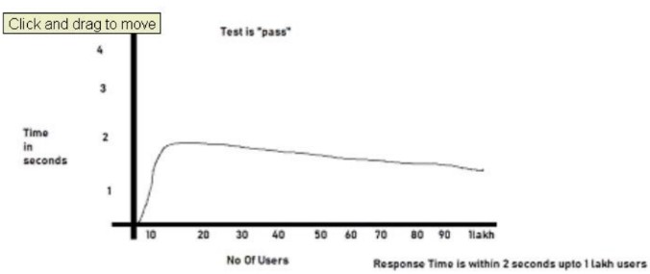

**Types of Performance Testing**

1. Load testing
2. Stress testing
3. Volume testing
4. Soak testing

1. *Load testing*

Testing the stability and response time of an application by applying load less than or equal to designed no. of users is called Load testing.

1. *Stress testing*

Testing the stability and response time of an application by applying load more than the designed no. of users is called Stress testing.

1. *Volume testing*

Testing the stability and response time of an application by transferring huge volume of data is called Volume testing.

1. *Soak testing*

Testing the stability and response time of an application by applying load continuously for some particular period of time is called Soak testing.

**For what kind of applications, we should do Performance Testing?**

1. Any application which generates lot of revenue
2. Any application which is used by multi-users